Tableau Assignment - Citi Bike Analytics

GW Data Boot Camp

August 3, 2019

Instructor Reed Hyde

Student Irby Hunter

**Data Visualization 1.0**

**End Station Name Trip Data Bar Chart**

Utilizing the 201306 Citibike data set a sample bar chart was created. The End Station Name was paced in the columns tab. The Trip Duration sum was placed in the rows tab. Gross visualization reveals that majority of the trips are between 2M and 5M. A conclusion may be drawn that when travel requires a distance greater than 5M an alternative means of transportation is either preferred or required. Challenges faced include the large number of end stations. More significant analysis may be conducted with placing the end stations into categories by neighborhoods.

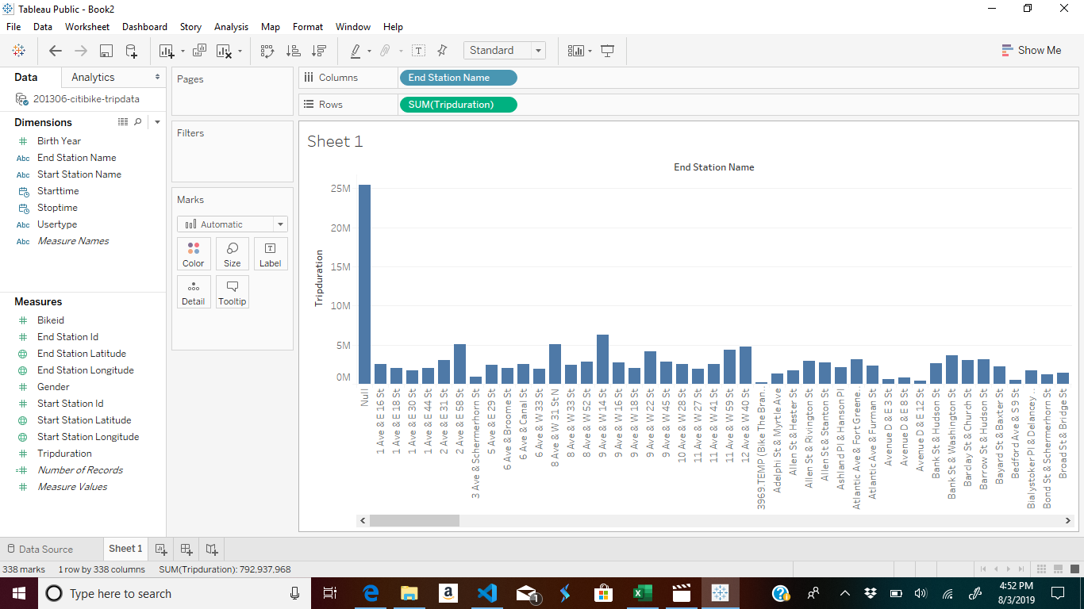

**Data Visualization 2.0**

**End Station Name Trip Sample Pie Chart**

Utilizing the 201306 Citibike data set a sample pie chart was created. The End Station Name was paced in the color tab. The Trip Duration sum was placed in the size and angle tab. Gross visualization reveals that a chart that is not useful for human analysis. A conclusion may be drawn that no one particular end station has a greater market share than the other end stations. Challenges faced include the large number of end stations. More significant analysis may be conducted with placing the end stations into categories by neighborhoods.

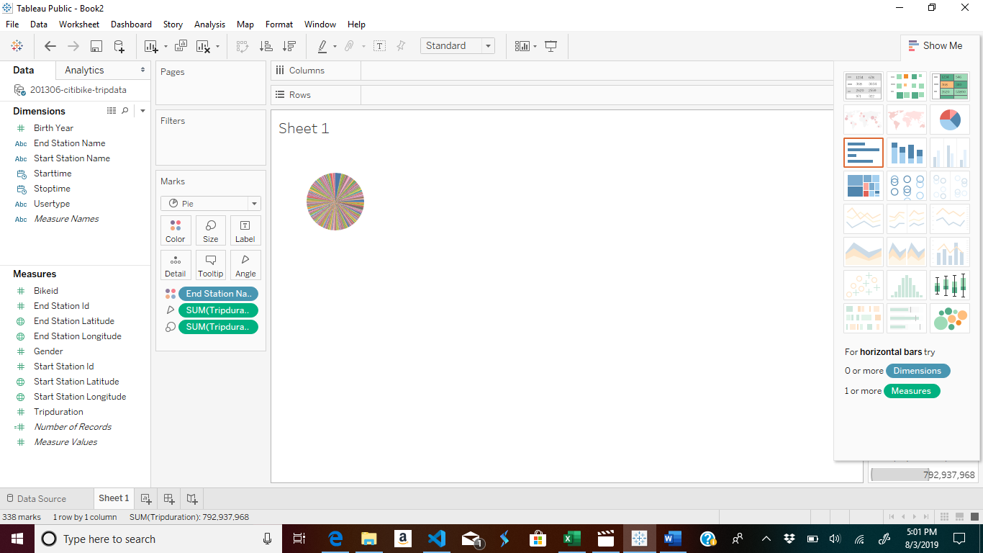

**Data Visualization 3.0**

User Type Customer vs Subscriber Trip Duration

Utilizing the 201306 Citibike data set a descriptive pie chart was created. The User Type was placed in the color and label tab. The Trip Duration sum was placed in the size and angle tab. Gross visualization reveals that a 65% non- subscribing customer and 35% subscribers. A conclusion may be drawn that a marketing campaign in required to increasing the number of non- subscribing customer.

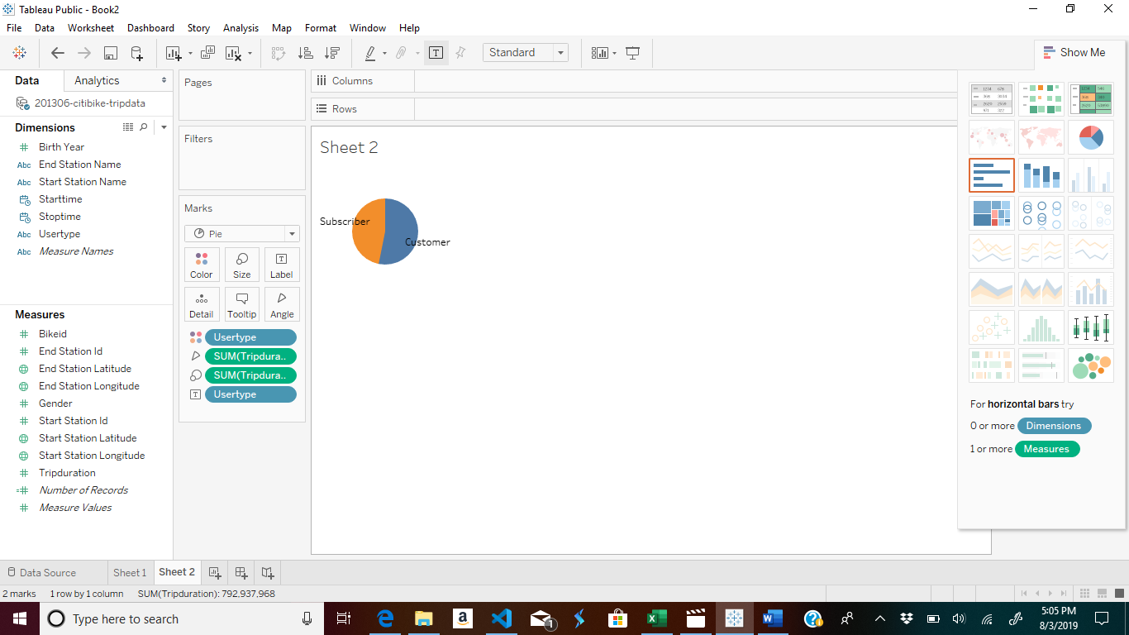

**Data Visualization 4.0**

Map

Utilization by Start Station Color Map

Utilizing the 201306 Citibike data set a map was created. The Start Station Longitude was placed in the columns tab. The Start Station Latitude was placed in the rows. The Trip Duration sum was placed in the color tab. Gross visualization reveals that dark blue areas represent start stations with higher utilization which is identified by the sum of the trip duration (rental). A conclusion may be drawn that decrease in inventory be needed in the very light areas on the map.

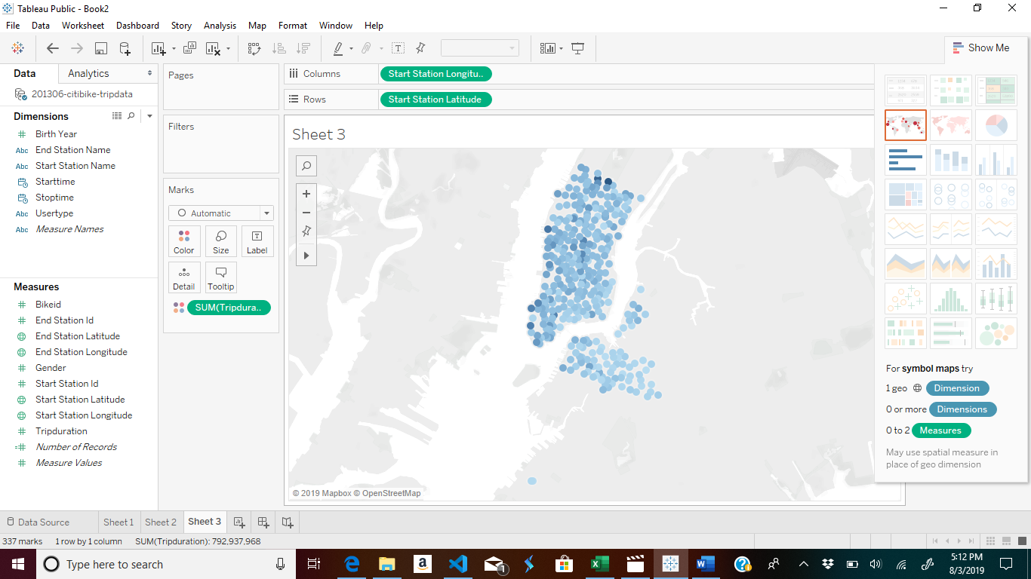

**Data Visualization 5.0**

Map

Variable is the utilization by bike ID Color Map

Utilizing the 201306 Citibike data set a map was created. The Start Station Longitude was placed in the columns tab. The Start Station Latitude was placed in the rows. The Bike ID sum was placed in the color tab. Gross visualization reveals that dark blue areas represent Bike ID utilization. A conclusion may be drawn that maintenance support may be required in dark areas of the map.

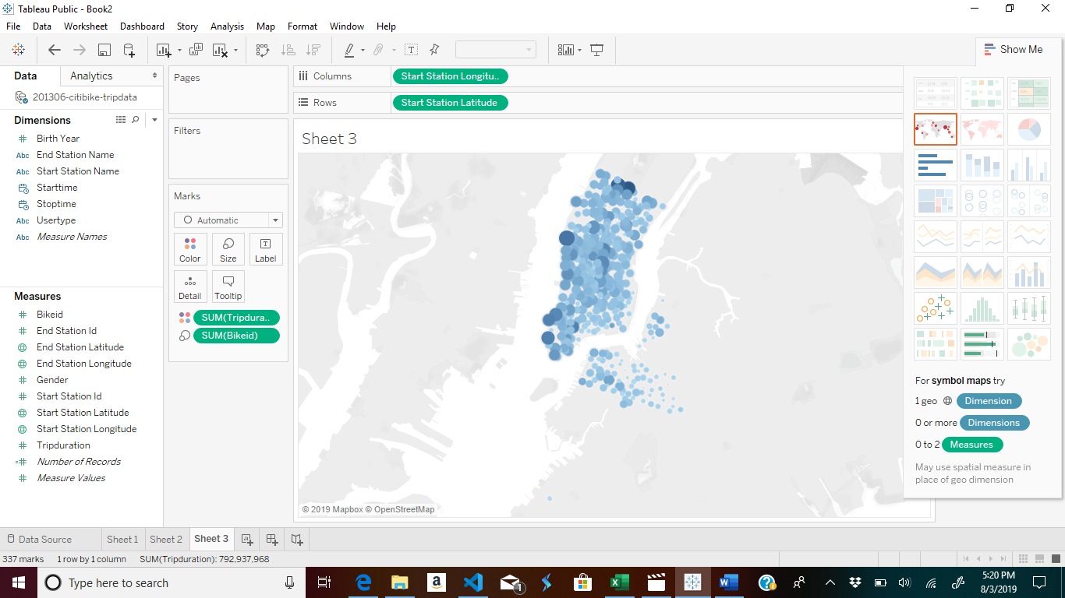

**Data Visualization 6.0**

Map

Utilization by End Station Color Map

Utilizing the 201306 Citibike data set a map was created. The End Station Longitude was placed in the columns tab. The End Station Latitude was placed in the rows. The Trip Duration sum was placed in the color tab. Gross visualization reveals that dark blue areas represent enf stations with higher utilization which is identified by the sum of the trip duration (rental). A conclusion may be drawn that decrease in inventory be needed in the very light areas on the map.

End Station Longitude End Station Latitude Trip Data Color

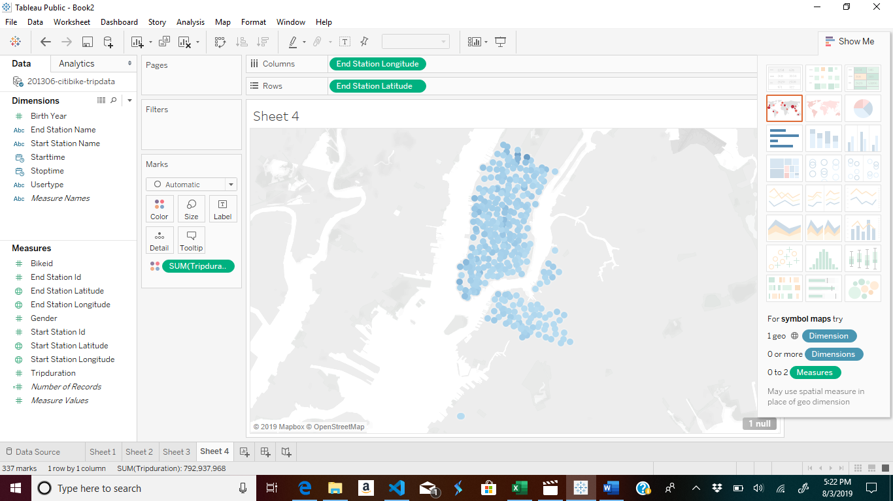

**Data Visualization 7.0**

Top 10 stations in the city for starting a journey

Utilizing the 201306 Citibike data set a bar char was created. The bar chart displays the top ten stations by starting a journey. The Start Station is in the column. The sum of Number records is in the rows. A conclusion may be drawn that an increase in inventory may be needed in the top ten stations.

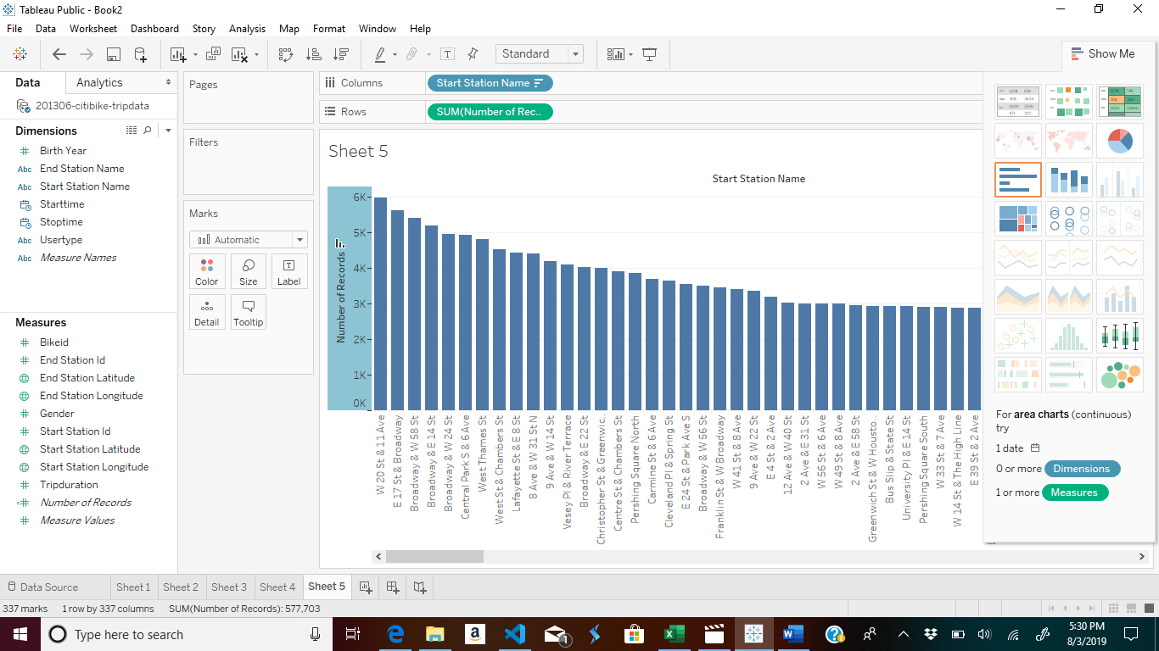

**Data Visualization 8.0**

Bottom 10 stations in the city for ending a journey

Utilizing the 201306 Citibike data set a bar chart was created. The bar chart displays the top ten stations by starting a journey. The End Station is in the column. The sum of Number records is in the rows. A conclusion may be drawn that this may be the normal business ebbs and flows.

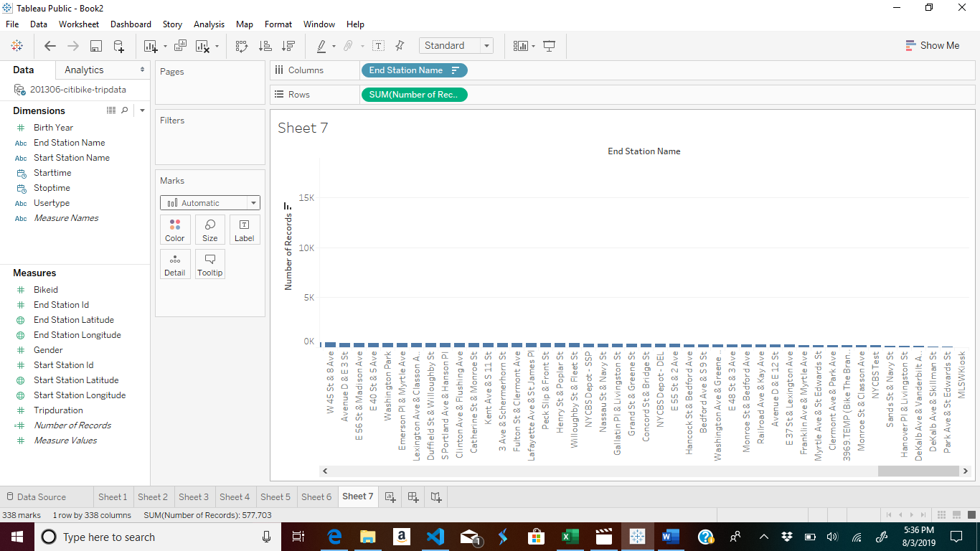

**Data Visualization 9.0**

Average trip duration change by age

Utilizing the 201306 Citibike data set a line graph was created. The line graph bar displays the average trip duration by age. The Birth Year is in the column. The average Trip Duration sum of is in the rows. A conclusion may be drawn that marketing to be geared towards all adult ages.

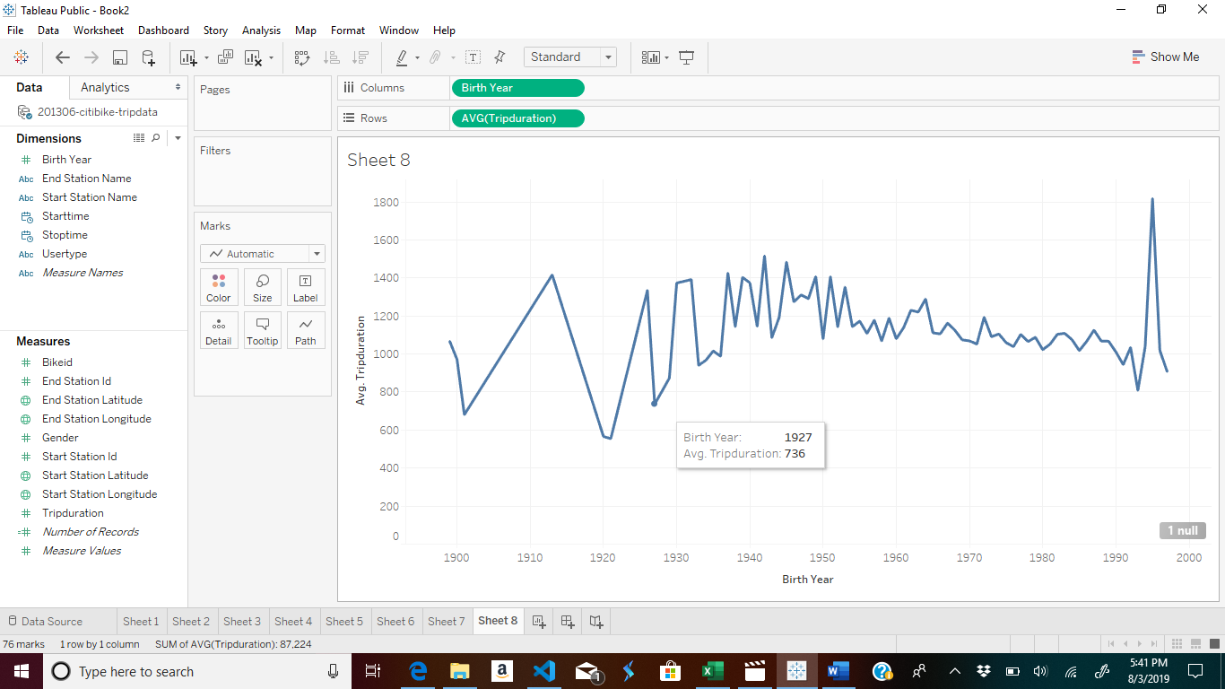

**Data Visualization 10.0**

Which bikes (by ID) are most likely due for repair or inspection in the timespan?

Utilizing the 201306 Citibike data set a bar chart was created. The bar chart displays the trip duration by bike id. The Bike Id is in the column. The sum of Trip duration is in the rows. A conclusion may be drawn that this may be maintenance should be scheduled by time i.e. calendar not usage. This will avoid bike IDs being potentially missed during maintenance protocols.

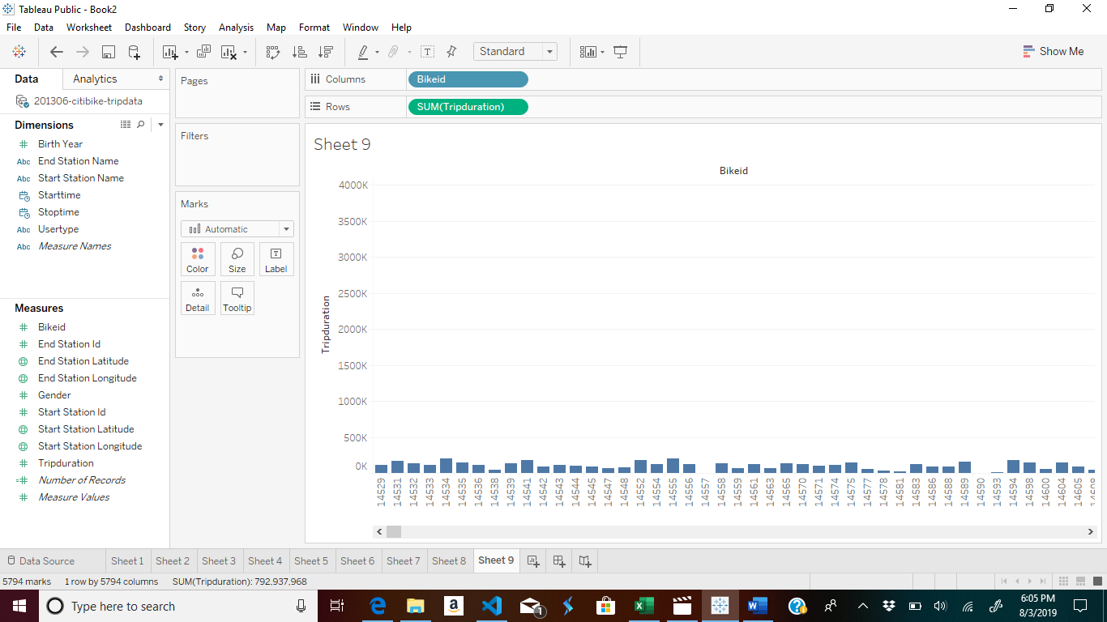

**Data Visualization 10.0**

How variable is the utilization by bike ID?

Utilizing the 201306 Citibike data set a bar chart was created. The bar chart displays the trip duration by bike id. The Bike Id is in the column. The sum of Trip duration is in the rows.

